Martha and Mary, friends of Jesus
Reading: Luke 10:38-42
Jesus and his disciples went on their way. Jesus came to a village where a woman named Martha lived. She welcomed him into her home. She had a sister named Mary. Mary sat at the Lord’s feet listening to what he said. But Martha was busy with all the things that had to be done. She came to Jesus and said, “Lord, my sister has left me to do the work by myself. Don’t you care? Tell her to help me!”
“Martha, Martha,” the Lord answered. “You are worried and upset about many things. But few things are needed. Really, only one thing is needed. Mary has chosen what is better. And it will not be taken away from her.”

Thought about the reading
Martha, Mary and their brother Lazarus lived in a village near Jerusalem. They were good friends of Jesus. When Jesus visited Jerusalem, it is likely that he stayed at their house.
In today’s story, Jesus visited Mary and Martha. Martha was very busy, getting everything ready for her visitor. Maybe she was cleaning the house and cooking a meal. She felt cross that her sister Mary was not helping her.
Mary was sitting by Jesus, listening to what he said.
Jesus understood that Martha was worrying about all the things that needed to be done when a friend came to visit. But he said that only one thing was really important and that was to spend time with the friend and to listen to them.
If we want to be a good friend, we need to make time to be with our friends and to listen to them.
If we want to be a good friend of Jesus, we need to make time to be with him, when we can pray and read the Bible.

Prayer
Lord Jesus, please forgive me for all the times when I am too busy to spend time with my friends, or with you.
Please help me to find time to be with my friends. Please help me to find time to be with you to pray and read the Bible.
Amen

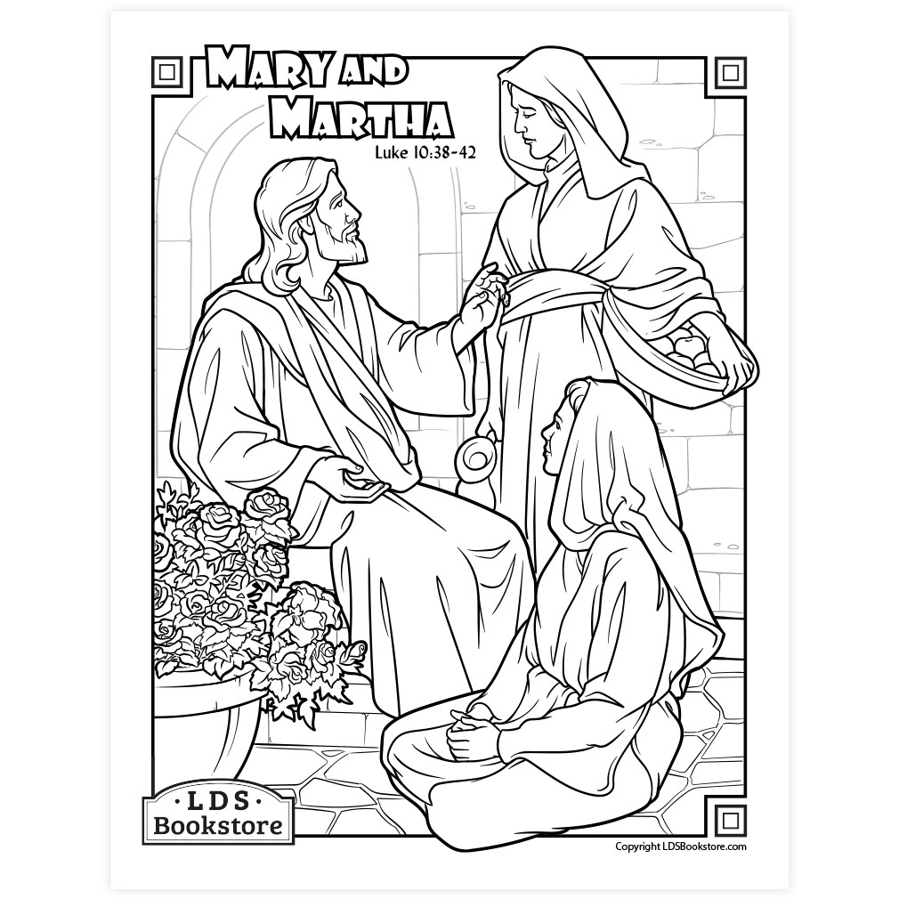
Martha and Mary

Cambridge Causeway

Summer 2024
Bible Study notes

Heroes of the Bible Part 2
2. Martha and Mary,
friends of Jesus
By Chrissy Cole

